CUSTOM BOOTCAMP
Azure Storage Types

Azure Storage
- Azure Storage is a cloud-based storage service provided by Microsoft as part of the Microsoft Azure cloud platform.
- It offers a variety of storage solutions that cater to different data storage needs, including file storage, object storage, and more.
- Azure Storage is designed to be highly available, durable, and scalable, making it suitable for a wide range of applications and use cases.

Blob Storage
- Blob Storage, short for "Binary Large Object" storage, is designed to store and manage large amounts of unstructured data, such as documents, images, videos, and backups.
- It offers three tiers: Hot, Cool, and Archive, with varying costs and access times based on the frequency of access.

File Storage
- Azure File Storage provides fully managed file shares that can be accessed using the standard Server Message Block (SMB) protocol.
- It's suitable for migrating on-premises file shares to the cloud, as well as for sharing files across virtual machines.

Queue Storage
- Azure Queue Storage offers a message queuing service for decoupling and asynchronous communication between application components.
- It's commonly used for building scalable and resilient applications.

Table Storage
- Azure Table Storage is a NoSQL data store that provides key/attribute store capabilities for semi-structured data.
- It's suitable for applications that require schema-less data storage and fast access to data.

Disk Storage
- Azure Disk Storage provides managed virtual hard disks (VHDs) that can be attached to virtual machines.
- These disks can be used for operating system disks or data disks and come in different types, such as Standard HDD, Standard SSD, Premium SSD, and Ultra Disk.

Data Lake Storage
- Azure Data Lake Storage is designed for big data analytics workloads.
- It supports massive data volumes and high-throughput access, making it suitable for scenarios involving data exploration, analysis, and machine learning.

Shared Access Signatures (SAS)
- Azure Storage allows you to generate SAS tokens that grant limited access to specific resources.
- This is useful for providing temporary access to data without exposing full account credentials.

Azure Backup:
- While not part of Azure Storage per se, Azure Backup is closely related and provides a way to back up and restore data from various Azure services, including Azure VMs, SQL databases, and more.

Azure Storage Accounts
- An Azure Storage Account is a fundamental Azure resource that provides a way to store and manage various types of data in Microsoft Azure.
- It serves as a logical container for data storage services like Blob Storage, File Storage, Queue Storage, Table Storage, and Disk Storage.
- Each storage account has a unique namespace within the Azure cloud, and you can have multiple storage services within a single storage account.

Storage Account Types
Azure offers several types of storage accounts to cater to different performance and cost requirements:
- General-purpose v2: Offers a balance between performance and features, suitable for most storage scenarios.
- General-purpose v1: Older version with fewer features compared to v2.
- Blob Storage: Optimized for massive-scale object storage, suitable for scenarios like serving images or videos directly to web browsers.
- Premium: Offers high-performance, low-latency storage using SSDs, suitable for I/O-intensive workloads.

Replication Options
Azure Storage Accounts support various replication options to ensure data durability and availability:
- Locally Redundant Storage (LRS): Data is replicated within the same datacenter.
- Geo-Redundant Storage (GRS): Data is replicated to a secondary datacenter in a different region.
- Zone-Redundant Storage (ZRS): Data is replicated across availability zones within a region (for specific services like Blob Storage).

Azure Storage Redundancy Option
- Azure Storage offers different redundancy options to ensure data availability, durability, and resilience in the face of failures.
- These options allow you to choose the level of redundancy that best suits your application's requirements and availability needs.
- Here are the primary redundancy options available for Azure Storage:
  - Locally Redundant Storage (LRS)
  - Geo-redundant storage (GRS)
  - Zone-redundant storage (ZRS)
  - Read-Access Geo-Redundant Storage (RA-GRS)
  - Premium and Ultra Disk Redundancy

Locally Redundant Storage (LRS):
- LRS stores multiple copies of your data within the same datacenter.
- This provides a level of redundancy to protect against hardware failures, but it does not protect against datacenter-level failures or regional outages.
- LRS is the most cost-effective option.

Geo-Redundant Storage (GRS):
- GRS provides additional redundancy by replicating your data to a secondary datacenter in a different geographic region, typically hundreds of miles away from the primary datacenter.
- This protects your data against datacenter-level failures and provides better resilience in case of regional outages.
- GRS is a good option for applications requiring higher availability.

Zone-Redundant Storage (ZRS):
- ZRS replicates your data across availability zones within a specific Azure region.
- Availability zones are physically separate datacenters within the same region.
- ZRS provides better protection against datacenter-level failures compared to LRS and can help maintain data availability even if an entire datacenter goes down.

Read-Access Geo-Redundant Storage (RA-GRS):
- This option is an extension of GRS.
- In addition to the primary and secondary copies of your data, RA-GRS provides read access to the secondary datacenter's copy.
- This can be useful for scenarios where you want to read data from the secondary location in the event of an outage in the primary location.

Premium and Ultra Disk Redundancy:
- Premium and Ultra Disks provide redundancy within the same availability zone by replicating data across different fault domains and update domains.
- This ensures high availability and durability for your virtual machine disks.

Note
- When choosing a redundancy option, consider the trade-offs between cost, availability, and data durability.
- For critical applications that require minimal downtime and data loss, using a redundancy option like GRS or ZRS is recommended.
- For applications where cost is a primary concern, LRS may be suitable.

Azure Storage Tiers
- Azure Storage provides different storage tiers within the Blob Storage service to optimize costs and performance based on the access patterns of your data.
- Each storage tier offers different pricing and access characteristics.
- The main storage tiers available are:
  - Hot Access Tier
  - Cool Access Tier
  - Archive Access Tier

Hot Access Tier
- Description: The Hot tier is designed for frequently accessed data that requires low-latency access times. It's suitable for data that is accessed and modified frequently.
- Use Cases: Applications that require fast and immediate access to data, such as frequently accessed images, videos, or transactional data.
- Performance: Lower access costs but higher storage costs compared to Cool and Archive tiers.
- Access Latency: Minimal access latency.

Cool Access Tier
- Description: The Cool tier is optimized for infrequently accessed data that requires lower storage costs. Data stored in the Cool tier has slightly higher access costs compared to the Hot tier.
- Use Cases: Backups, long-term archival, and data that is accessed less frequently but still needs to be available when required.
- Performance: Lower storage costs compared to the Hot tier, with slightly higher access costs.
- Access Latency: Slightly higher access latency compared to the Hot tier.

Archive Access Tier
- Description: The Archive tier is designed for rarely accessed data with the lowest storage costs but longer retrieval times. Data in the Archive tier has higher access costs compared to both the Hot and Cool tiers.
- Use Cases: Long-term archival data that is rarely accessed but needs to be retained for compliance or regulatory reasons.
- Performance: Lowest storage costs but highest access costs compared to Hot and Cool tiers.
- Access Latency: Longer retrieval times compared to Hot and Cool tiers.

Blob Storage
- Blob Storage, short for "Binary Large Object" storage, is a cloud-based storage service provided by Microsoft Azure that is optimized for storing and managing massive amounts of unstructured data.
- It's a key component of Azure Storage and is commonly used for various data storage and sharing scenarios.
- Blob Storage is designed to be highly available, durable, and scalable, making it suitable for a wide range of use cases.

Data Lake Gen2 Storage
- Azure Data Lake Storage Gen2 is a powerful cloud-based storage solution provided by Microsoft Azure that combines the capabilities of a data lake with the performance, scalability, and security features of Azure Blob Storage.
- It's designed to store and analyze massive volumes of structured and unstructured data, making it well-suited for big data analytics, machine learning, data warehousing, and other data-intensive workloads.

Blob Storage VS Data Lake Gen2 Storage
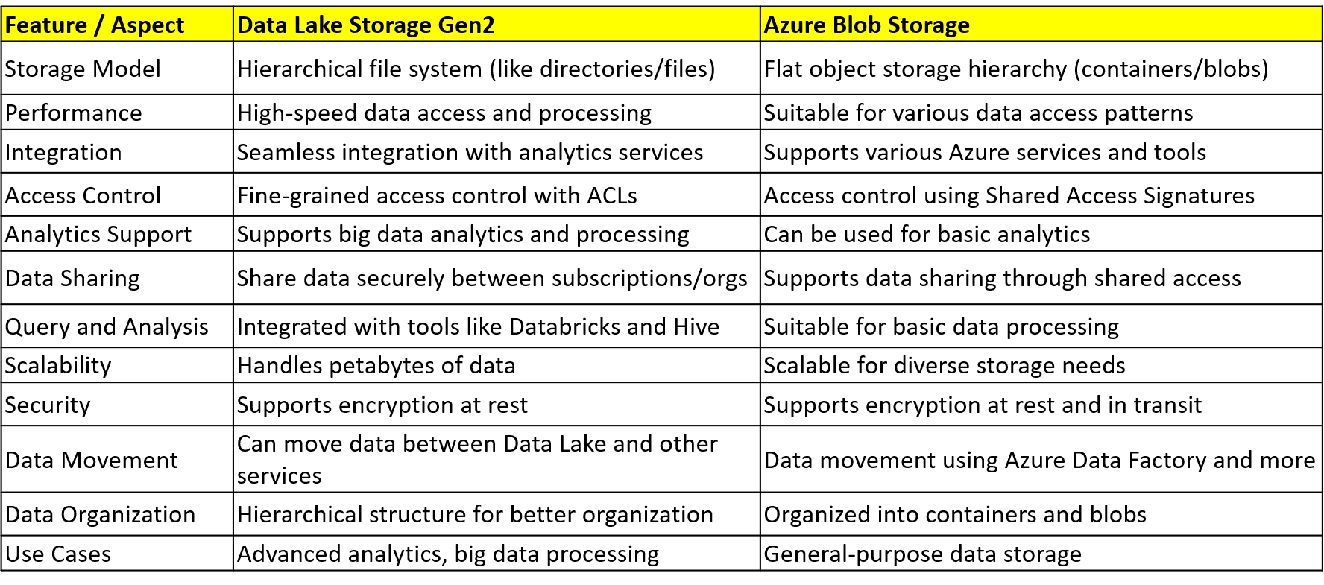

File Storage
A file storage is a single piece of information stored inside a folder.
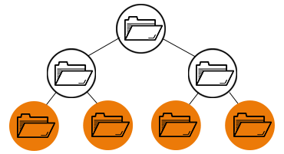

Block Storage
Block storage chops data into blocks and stores them as separate pieces. Each block of data is given a unique identifier, which allows a storage system to place the smaller pieces of data wherever is most convenient.
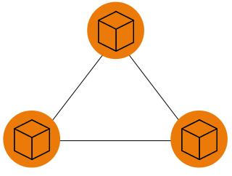

Object storage
Object storage also known as object-based storage, is a flat structure in which files are broken into pieces and spread out among hardware. In object storage, the data is broken into discrete units called objects and is kept in a single repository, instead of being kept as files in folders or as blocks on servers. Object storage requires a simple HTTP API, which is used by most clients in all languages.
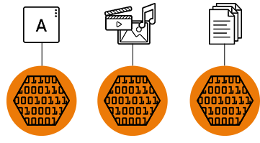

Azure Storage Tiers
Azure storage offers different access tiers so that you can store your blob data in the most cost-effective manner. Azure Storage access tiers include:
- Hot tier - An online tier optimized for storing data that is accessed or modified frequently. The hot tier has the highest storage costs, but the lowest access costs.
- Cool tier - An online tier optimized for storing data that is infrequently accessed or modified. Data in the cool tier should be stored for a minimum of 30 days. The cool tier has lower storage costs and higher access costs compared to the hot tier.
- Cold tier - An online tier optimized for storing data that is infrequently accessed or modified. Data in the cold tier should be stored for a minimum of 90 days. The cold tier has lower storage costs and higher access costs compared to the cool tier.
- Archive tier - An offline tier optimized for storing data that is rarely accessed, and that has flexible latency requirements, on the order of hours. Data in the archive tier should be stored for a minimum of 180 days.

Azure Queue Storage
Azure Queue Storage is a service for storing large numbers of messages. You access messages from anywhere in the world via authenticated calls using HTTP or HTTPS. A queue message can be up to 64 KB in size. A queue may contain millions of messages, up to the total capacity limit of a storage account. Queues are commonly used to create a backlog of work to process asynchronously.

Azure Cosmos DB vs Azure Storage: What are the differences?
Azure Cosmos DB and Azure Storage are cloud-based storage services. They differ in terms of their data models, scalability, querying capabilities, and storage options. Here are the key differences between them:
- Data Model: Azure Cosmos DB is a globally distributed, multi-model database service that supports various data models, including key-value, document, columnar, and graph. Azure Storage, on the other hand, primarily offers a simple object storage service with a key-value data model. It is designed for storing unstructured data such as blobs, files, queues, and tables.
- Scalability: Azure Cosmos DB is built for global scalability and can automatically scale throughput and storage across multiple regions. It offers elastic scalability with fine-grained control over performance and cost. Azure Storage also provides scalability, but it requires manual configuration and management of storage accounts and blob containers to handle increased load. Scaling Azure Storage may involve sharding data across multiple storage accounts.
- Querying Capabilities: Azure Cosmos DB supports rich query capabilities across various data models. It provides a SQL-like query language called SQL API for querying JSON documents. It also supports other APIs like Gremlin for graph data and MongoDB API for document-oriented querying. Azure Storage, on the other hand, does not offer built-in query capabilities. Retrieving data from Azure Storage typically involves directly accessing the stored objects using their unique keys.
- Storage Options: Azure Cosmos DB provides storage for application data, along with built-in features like automatic indexing, data partitioning, and replication. It is a fully managed service that abstracts away the underlying storage implementation. Azure Storage, on the other hand, offers different types of storage options, including Blob storage for large object data, Queue storage for messaging, Table storage for structured NoSQL data, and File storage for file shares.
- Consistency Models: Azure Cosmos DB offers multiple consistency models, allowing developers to choose the desired level of data consistency based on their application requirements. It provides options like strong consistency, bounded staleness, session consistency, and eventual consistency. Azure Storage, on the other hand, primarily provides eventual consistency for read operations. It may take some time for changes made to Azure Storage to propagate across different regions.

Azure Active Directory
Azure Active Directory integration for authorizing request to blob, queue, and table resources. Microsoft recommends using Azure AD credentials to authorize request to data, when possible, for optimal security and ease of use. We can use azure role-based access control to manage the security principal permission to blob, queue, and table resources in the storage account.

